**[Shooting The Massad Ayoob Group MAG Qualifier](https://www.spicetac.com/shooting-the-massad-ayoob-group-mag-qualifier/)**

**What is the MAG Qual?**

The Massad Ayoob Group (MAG) Qual is a 60-round handgun qualification course designed by Massad Ayoob in the early 1980s. It draws from a variety of law enforcement qualification courses. It requires one-handed shooting, speed reloading, various cover positions and different shooting stances. The timed course of fire is shot at 4, 7, 10 and 15 yards.

A cardboard IPSC/USPSA target is commonly used, but an IDPA target can be substituted.

**When used for the MAG Qual, the targets (IPSC left and IDPA right), are scored as shown here.**

A shot timer is typically used for a start and stop signal. Any shots not fired in the allotted time at the 4, 7 or 10 yard lines are allowed to be made up at the 15 yard position. Shots made up at 15 yards, however, must be fired within the time allotted for the 18 other shots required at that distance. Late shots at any distance are assessed a 10 point penalty per shot.

A bullet hole that breaks the perforated scoring line between two scoring zones is given the higher point value. 300 points are possible and a passing score is 75% or 225 points. If a 5-shot handgun is used, 5 shot strings are fired for a total of 50 shots and 250 points are possible with 188 points needed to pass.

The classifier is shot at standard speed in the Massad Ayoob Group (MAG) Level 1 class (MAG-40). As classes advance to Level 2 (MAG-80), Level 3 (MAG-120) and Level 4 (MAG-180) a passing score is required at double, triple and quadruple speeds respectively.

**See our class reviews:**[**MAG-40**](https://www.spicetac.com/mag-40-massad-ayoob-group-class-overview)**,**[**MAG-80**](https://www.spicetac.com/mag-80-massad-ayoob-group-class-overview)**and**[**MAG-120**](https://www.spicetac.com/mag-120-massad-ayoob-group-class-overview)

**Massad Ayoob Group MAG Qual shot at Standard Speed**

**MAG Qual Course of Fire**

**Massad Ayoob Group MAG Qualifier (60 rounds)**

**4 yards (Qualifications from NRA Police Service Pistol Course)**

String 1 (Seconds: **Standard Speed: 8**, Double Speed: 4, Triple Speed: 2.67, Quad Speed: 2)

- Start Position: Weak hand low ready

- 6 rounds weak hand only

String 2 (Seconds: **Standard Speed: 8**, Double Speed: 4, Triple Speed: 2.67, Quad Speed: 2)

- Start Position: Strong hand on holstered pistol. (Alternatively, from low ready)

- 6 rounds strong hand only

**7 yards (FBI Practical Police Course)**

String 1 (Seconds: **Standard Speed: 25**, Double Speed: 12.5, Triple Speed: 8.33, Quad Speed: 6.25)

Start Position: Pistol holstered, hand off pistol. (Alternatively, from low ready)

- 6 rounds free style

- reload

- 6 rounds free style

**10 yards (New England Police Course)**

String 1 (Seconds: **Standard Speed: 75**, Double Speed: 37.5, Triple Speed: 25, Quad Speed: 18.75)

- Start Position: Low ready

- 6 rounds from cover crouch

- reload

- 6 rounds from high kneeling

- reload

- 6 rounds from low kneeling

**15 yards (Hybrid of FBI PPC and NRA PPC courses)**

String 1 (Seconds: **Standard Speed: 90**, Double Speed: 45, Triple Speed: 30, Quad Speed: 22.50)

Start Position: Pistol holstered, Hand off pistol. (Alternatively, from low ready)

- 6 rounds from Weaver Stance

- reload

- 6 rounds from Chapman Stance

- reload

- 6 rounds from Isosceles Stance

**Note:** Women may substitute the Chapman or Isosceles stance in place of Weaver if they choose.

**Trending:**[**Best Handguns for Beginners & Home Defense**](https://www.spicetac.com/best-handgun-for-beginners-home-defense/)**,**[**Best Places to Buy Ammo Online**](https://www.spicetac.com/best-places-to-buy-ammo-online/)

**Over the years the author has used a variety of handguns to shoot the MAG Qual including the HK P7M8, Sig P220, Sig P220ST, Glock 17, 19, 26, 34, 43X, Dan Wesson 1911, Les Baer 1911, Springfield Armory XDS-9, Smith Wesson 342 and 686.**

**Tips for shooting the standard speed MAG Qual**

Let's start with the basics. You will want a pistol and ammunition that are reliable together. You need a holster that is easy to use and does not require you to fiddle with it, especially in a way that could cause you to cross your hand or body while drawing or reholstering.

Safety is paramount and at no time should your pistol cross your support hand during drawing or reholstering.

Drawing and reholstering should be smooth and fumble free. While reloads do not have to be particularly fast, they do need to be smooth and free from fumbles and bobbles.

**Note:** The following "Five Point Checklist" is a short summary of what is required to make a good shot on target. Be sure that you are doing due diligence to each element.

**1. Strong stance.**

**2. High hand (on the gun)**

**3. Crush grip.**

**4. Front sight focus.**

**5. Smooth trigger press.**

Beyond the basics, it's important to have a good feel for the time required at each distance. The videos in this article will give you an idea of the proper cadence of shots required to make the times. Going too fast can be almost as bad for your score as going too slow.

**Massad Ayoob Group MAG Qual shot at Double Speed**

**Massad Ayoob Group MAG Qual shot at Triple Speed**

**Tips for shooting the faster MAG Quals (Double, Triple & Quad)**

As the quals get faster there is less room for error on your part, and also for your equipment.

**Reliability:** Your gun and ammo must work 100%. On the faster quals there is simply no time to clear malfunctions. Managing the human part of this effort is hard enough, if your gun is not perfectly reliable get one that is.

**Reloads:** You have to nail the reloads. Mags must drop free without hesitation. You must be able to easily reach the mag release button and press it, and the mag must fly out when you do. If you have to shake the mag out or pull it out with your support hand, even occasionally, then you have a problem you need to fix. Inserting the fresh mag must be bobble free. Dry-fire practice is your friend here.

It's generally more difficult to consistently make smooth/fast reloads with a single stack auto than with a double stack gun. The fact that the magwell is narrower is only one part of the problem. Magazines for double stack autos taper near the top and that geometry makes them want to go into the wide magwell of the double stack auto. Single stack guns don't have that going for them. A magwell can help this somewhat. This is one factor among many to consider when you are choosing equipment.

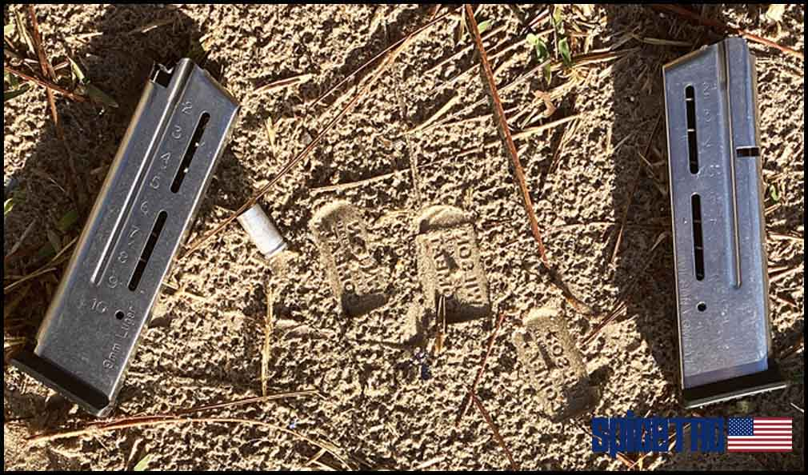

**Wilson Combat magazines make a good impression**

**Practice:** There is no substitute for practicing the quals. A timer will be extremely helpful so you can practice to the required times. You can see the timing needed for each stage of the various quals in the accompanying videos.

**Basics:**Once everything else is squared away it will always come down to sight alignment and trigger press. 5-Step checklist to the rescue. Learn it. Live it. Love it.

**Special thanks to Herman Gunter III and the knowledgeable MAG Staff for their helpful suggestions on this section.**

**Note:**  For purposes of determining if a shot is fired late, a 0.3 second reaction time is taken into account. This is due to the time it takes to react to a signal, or a beep.

For this reason, shots fired up to 0.3 seconds after the stop beep are not considered late or penalized. This becomes more of a factor during the faster quals like the Triple and Quadruple Speed.

**Massad Ayoob Group MAG Qual shot at Quad Speed (See full length uncut 13-minute video**[**here**](https://youtu.be/LTZStcT4nyA)**)**

**Quad Speed MAG Qual - Shooting Tips**

By taking the Standard MAG Qual times and dividing by four you have the Quad Speed Qual. Everything else remains the same. This Qual is shot during MAG-180, the fourth level class.

Shooting a good score on the Quad Speed Qual is a challenge. I shot it extensively for this article in order to get the score that I wanted and it took a lot of time, effort and ammo. Here is my advice specifically for anyone wanting to shoot their best on the Quad Speed Qual.

**A mag loader came in handy**

I found it useful to shoot each distance many times in practice. For example, one day I might shoot lots of 4 and 7 yard drills and the next day shoot a lot at 10 and 15 yards. Then, after you shoot the whole qual you can go back and work on the distance that gave you the most trouble.

**Tracking your performance allows you to see your improvement**

I kept a shooting log tailored to each distance to document my progress and it was very helpful. Special thanks to World Champion and top notch trainer Mike Seeklander for that suggestion. See his website here [Shooting-Performance](https://www.shooting-performance.com/).

**4, 7, 10, 15, 8, 25, 75, 90, 6, 6, 6!**

Finally, I found it useful to use different techniques at each distance and that may be a good way for you to approach it as well.

**Distance specific tips**

**4 Yards**

To make the very short time limit at this distance I found that having a target focus worked best for me. Looking just over the top of the pistol, I could confirm that it was pointed at the center of the target. Then a steady cadence of shots gets it done.

Some really good shooters whose opinions I value tell me that they are able to get good hits on the right handed string of fire here by starting to fire while their arm is still extending toward the target. To make this work you must get the gun up into your line of sight early. It's worth giving it a try to see if it can work for you.

**7 Yards**

Here I used a "shooting out of the notch" sight picture.

I sometimes had difficulty getting back to the sights here after coming from a target focus at 4 yards. Inadvertently using a target focus here generally resulted in some hits outside the A-zone for me.

Shoot 7 yards "out of the notch" with a tight grip and a front sight focus for each shot. Targeted dry fire practice will bring down your draw to first shot times and your reload times. All that's left then are the split times and with a tight grip and a front sight focus you can whittle those down too.

**10 Yards**

The nature of the shooting and the time allowed at 10 yards combine to make this string the least difficult of all the distances for me. I generally do not shoot out of the notch at this distance, even at quad speed, preferring to get a traditional sight picture for each shot. Especially with the stability of the kneeling positions, a good sight picture with a tight hold sends them all into the A zone!

10 yards is almost too far to be shooting out of the notch, but if you want to do it anyway, put the top of the front sight near the bottom third of the A-zone and your hits will be solid.

Reload while you move from standing to kneeling to save some time no matter the speed of the qual.

**15 Yards**

I found that the factory standard 0.125" wide front sight of my Dan Wesson 1911 pistol was not conducive to fast accurate shooting at 15 yards. I switched to a 0.100" wide front sight from Dawson and it helped.

When the front sight is too wide there is very little light on each side of it. Re-acquiring the sight picture between shots is slower. A thinner front sight means more daylight on each side and a faster sight picture.

At this distance I use a standard sight picture with the top of the front sight aligned with the top of the rear sight. At the slower qual speeds like standard and double speed, you almost have time to admire your perfect sight picture. At triple and quadruple speed you do not. Line them up and send it!

Performing each of the shooting stances (Weaver, Chapman & Isosceles) properly is key. A tight crush grip on the pistol minimizes muzzle rise. With Weaver you must have a strong push-pull on the pistol or excessive recoil will slow follow up shots. With Chapman you must pull hard into the straight arm to keep the muzzle down. And with Isosceles, use a crush grip and press both arms out hard.

Finally, if you have bad vision or aging eyes you will want to have corrective shooting glasses. Especially at this distance. For years this was a problem that I found very hard to solve. After trying several different corrective shooting glasses I recently settled on the Hunters HD Gold brand and am very happy.

A special shoutout and "Thank You" to Andrew, Barb, Stacy and others for motivating me to tackle this Quad Speed project!

**Impromptu Equipment Test**

While practicing the Quad Speed qualifier for this article, the Dan Wesson 1911 pistol that I was using was working so well that I decided to stop cleaning it and see how long it would go before it started to malfunction. It is after all an old-school 1911 and is supposed to be chock full of attitude and malfunctions if not properly pampered and coddled.

I decided that I would only clean the pistol if it started to malfunction, or once I completed the Quad Speed project with a perfect score recorded on video. Whichever occurred first!

I took care to keep the pistol well oiled with Lucas Extreme Duty Gun Oil, applying it every 200 rounds or so. But I did not clean or disassemble the pistol in any way during the test.

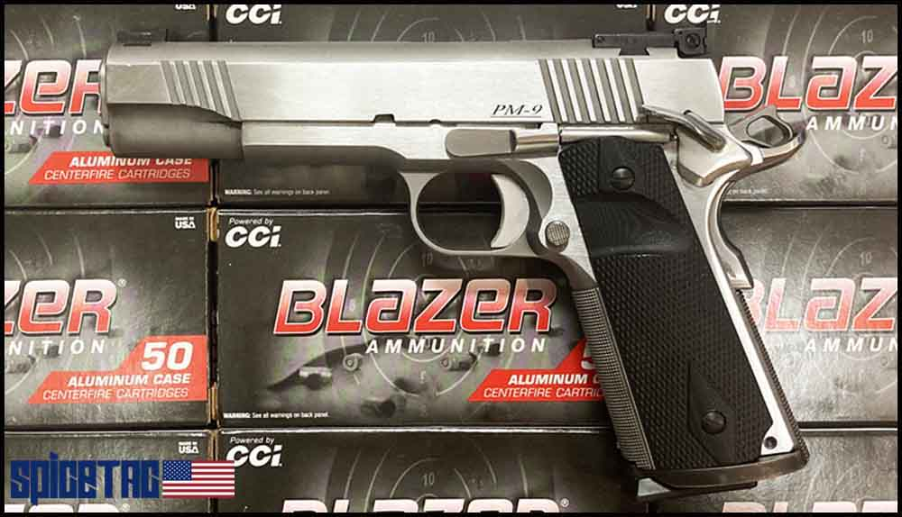

**This Dan Wesson 1911 pistol was used for the Double, Triple and Quad Speed Videos**

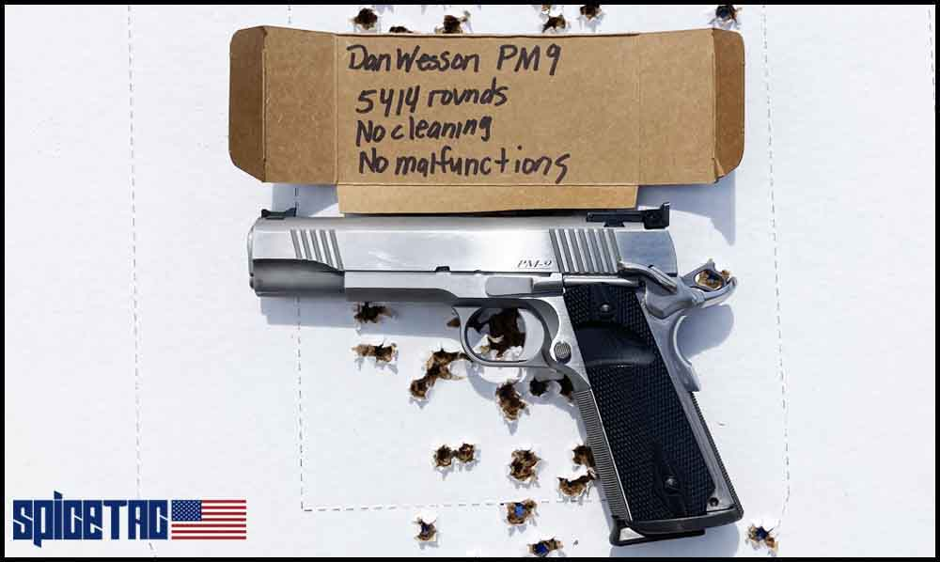

The final Quad Speed Qual attempt (in the video) was started at round count 5,354 since the pistol was last cleaned. Sixty rounds later, at round count **5,414**, both the Quad Speed project and the Dan Wesson 1911 test were complete.

**Verdict:** The pistol never failed in any way or had a malfunction of any kind despite being intentionally and ridiculously neglected by me. That means no failures to feed, failures to extract, failures to eject or failures of the slide to lock back on an empty magazine or failures of the magazines to fall free. 100% perfect function! At the end of the day the pistol delivered a perfect 300/300 score for me on a very difficult course of fire.

Dan Wesson and John Moses Browning, I salute you!

See our [Dan Wesson Pointman 1911 Review.](https://www.spicetac.com/dan-wesson-1911-review/)

**The Filthy Pistol After 5414 Malfunction-Free Rounds**

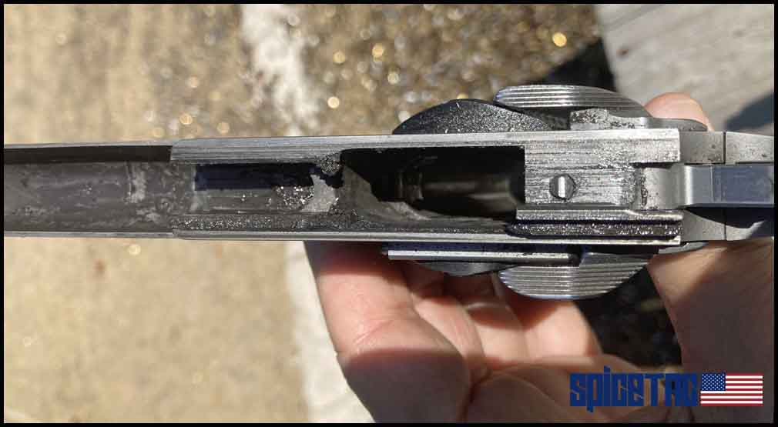

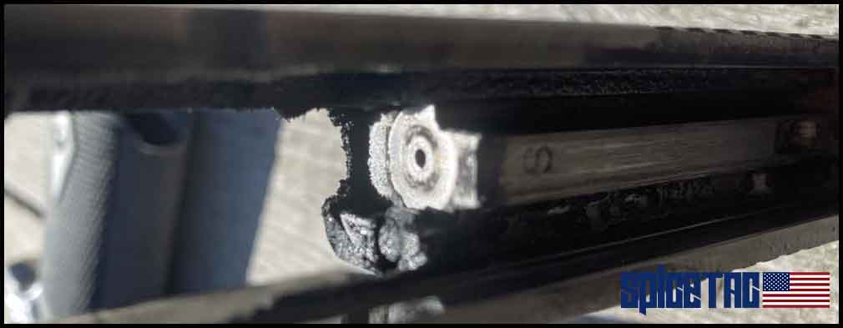

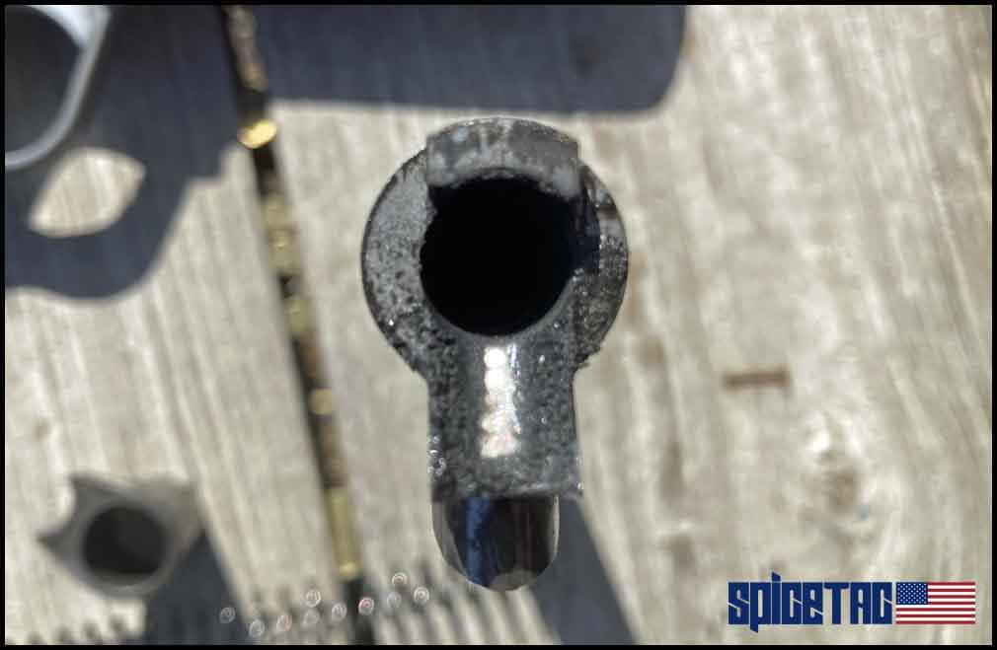

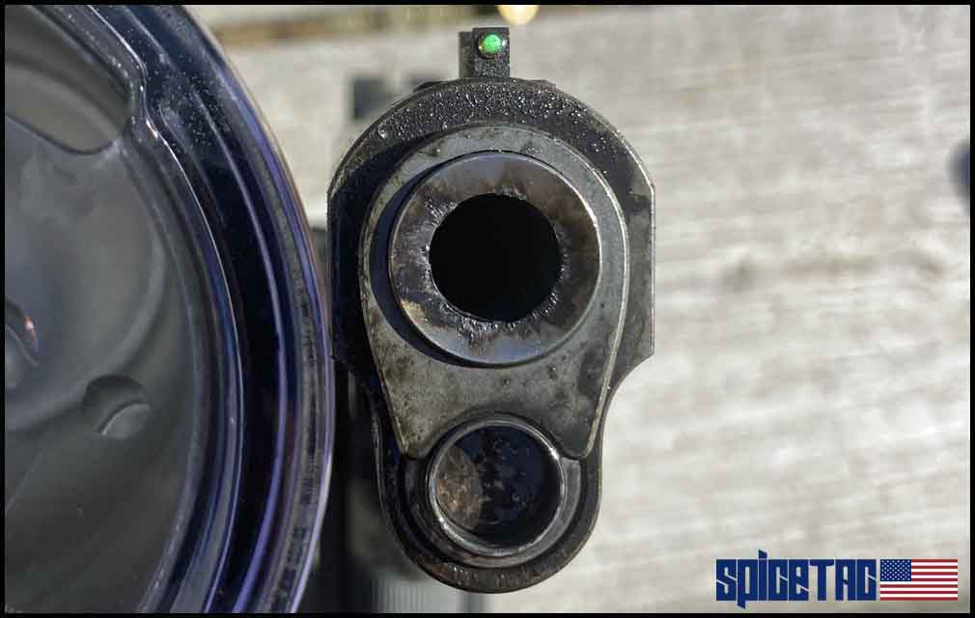

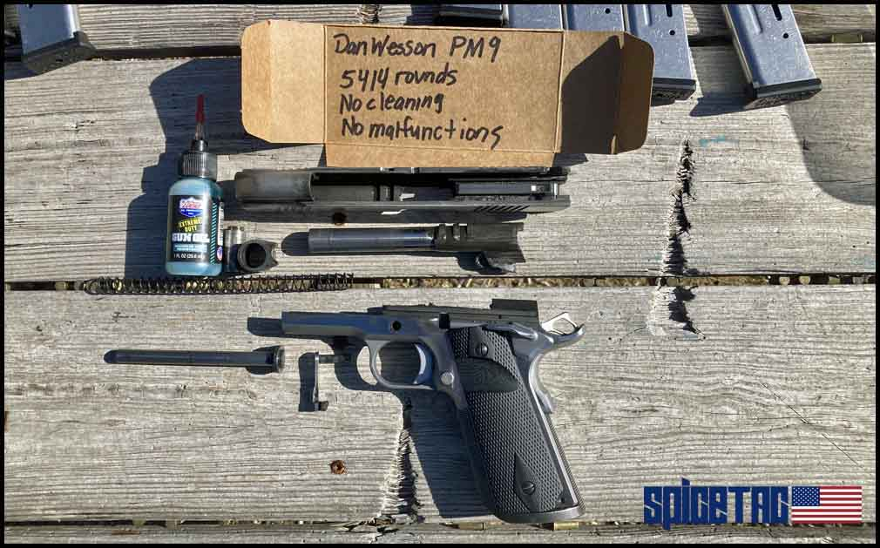

**Don't do what I did! Clean your guns!**

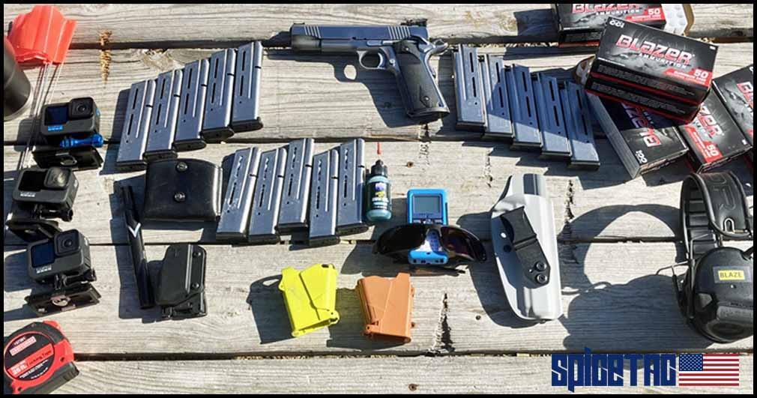

**This is the equipment that I used to shoot a 300/300 on the MAG Quad Speed Qual**

**My Quad Speed MAG Qual Equipment**

* **Pistol -** Dan Wesson 1911 9mm (Model PM-9) **Modifications:** Wilson Combat ambi thumb safety and medium length trigger, S&A magwell, full length recoil spring guide rod, Dawson narrow front sight, VZ G-10 grips.
* **Magazines -** Wilson Combat 10 round
* **Ammo -** Blazer 115 gr 9mm aluminum case FMJ
* **Holster -** Vedder LightTuck Inside the Waistband (IWB)
* **Mag pouches -** Blade-Tech single and Dillon Precision double
* **Gun oil -** Lucas Extreme Duty Gun Oil
* **Shot timer -** CED 7000
* **Mag loader -** Maglula
* **Safety glasses -** Hunters HD Gold

**See our class reviews:**[**MAG-40**](https://www.spicetac.com/mag-40-massad-ayoob-group-class-overview)**,**[**MAG-80**](https://www.spicetac.com/mag-80-massad-ayoob-group-class-overview)**and**[**MAG-120**](https://www.spicetac.com/mag-120-massad-ayoob-group-class-overview)